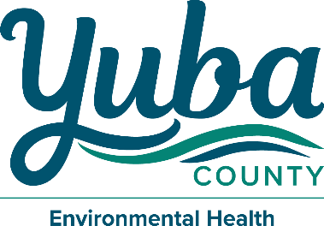
Mike Lee
Director – Community Development & Services Agency

Clark Pickell
Director – Environmental Health & CUPA

Government Center 915 8th Street, Suite 123
Marysville, California 95901-5273
(530) 749-5450 Fax (530) 749-5454

WATER QUALITY EMERGENCY NOTIFICATION PLAN

Name of Utility: | System #:
Physical Location:
Mailing Address:

The following persons have been designated to implement the plan upon notification by the Yuba County Environmental Health Department or by the State Water Resources Control Board Division of Drinking Water that an imminent danger to the health of water users exists:

CONTACT NAME | EMAIL ADDRESS | DAY PHONE | EVENING PHONE
Well Drilling Pump Company
Water Hauler

For a list of approved water haulers, visit: https://www.cdph.ca.gov/Programs/CEH/DFDCS/pages/fdbprograms/foodsafetyprogram/water.aspx

The implementation of the plan will be carried out with the following personnel:
CONTACT NAME | TITLE | DAY PHONE | EVENING PHONE
Erin Hochstrasser | Registered EH Specialist | (530) 749-5437 | (530) 822-6894
Scott Small | Valley District Engineer | (530) 224-3252 | N/A

If the above personnel cannot be reached, contact:
Office of Emergency Services (24 Hours)  Ask for “Division of Drinking Water Duty Officer” | (800) 852-7550 or (916) 845-8911
NOTIFICATION PLAN
STANDARD PLAN: Check if you agree to notify customers by door-to-door contact or written handout sheets. It is important that the people going door-to-door are coordinated and trained so that they distribute copies to the designated areas of the water system. Maps of the specific areas that the notices are to be distributed should be provided to the customers. Consideration must be given to special organizations (such as schools), non-English speaking groups, and outlying water users.

ALTERNATE PLAN: Check if you propose to use another method and attach the alternate plan.

Report Prepared by:
Signature:

Title: Date:

